EXPT NO: 2 | COMPARATIVE STUDY OF ACTIVATION FUNCTIONS AND OPTIMIZATION ALGORITHMS IN DEEP LEARNING
DATE: 26.7.26

PRE-LAB QUESTIONS

1. Purpose of an activation function in an ANN
An activation function introduces non-linearity into a neural network. Without it, stacking multiple layers would mathematically collapse into a single linear transformation, no matter how many layers you add. Activation functions let the network learn complex, non-linear patterns in data and decide whether/how strongly a neuron "fires" based on its input.

2. Sigmoid vs Tanh vs ReLU
- Sigmoid: Output range (0, 1). Smooth S-curve, output can be interpreted as a probability. Suffers from vanishing gradients at both extremes (saturates for large +/- inputs).
- Tanh: Output range (-1, 1). Zero-centered (unlike sigmoid), which usually helps training converge faster. Still saturates at extremes, so it also suffers vanishing gradients.
- ReLU: Output range [0, ∞). f(x) = max(0, x). Computationally cheap, doesn't saturate for positive inputs, so gradients flow well — but neurons can "die" (output 0 permanently) if inputs are always negative.

3. Why an optimization algorithm is required
Training a neural network means minimizing a loss function over potentially millions of parameters. An optimizer defines how the weights are updated using the gradients of the loss (backpropagation) so that the loss decreases over successive iterations, guiding the model toward a good (ideally global) minimum efficiently and stably.

4. Batch GD vs SGD vs Mini-Batch GD
- Batch Gradient Descent: Computes gradient using the entire dataset per update. Stable but slow and memory-heavy for large datasets.
- Stochastic Gradient Descent (SGD): Updates weights using one training sample at a time. Fast per-step but noisy/unstable convergence.
- Mini-Batch Gradient Descent: Uses small batches (e.g., 32, 64 samples) per update — a practical middle ground offering both speed and stability, and is the standard approach used in practice.

5. Role of Google Colab and GitHub in DL experiment management
Google Colab provides free, cloud-based GPU/TPU compute and a Jupyter-like environment, letting you train models without local hardware and easily share notebooks. Google Drive integration lets you persist datasets/models across sessions. GitHub provides version control — tracking changes to code/notebooks, enabling collaboration, maintaining experiment history, and ensuring reproducibility of results.

AIM
To analyze the impact of different activation functions and optimization algorithms on the performance of Artificial Neural Networks (ANNs) and to learn best practices for managing deep learning experiments using cloud-based tools and version control.

SOFTWARE REQUIREMENTS
- Python
- TensorFlow or PyTorch
- Google Colab
- GitHub
- Matplotlib

OBJECTIVES
Students will be able to:
- Understand the role of activation functions in neural networks.
- Visualize and compare commonly used activation functions.
- Evaluate the performance of different activation functions in ANN models.
- Analyze various gradient-based optimization algorithms.
- Compare optimizer convergence and model accuracy.
- Learn experiment management using Google Colab, Google Drive, and GitHub.
- Maintain reproducible deep learning experiments using version control.

PROCEDURE
PART A: VISUALIZATION OF ACTIVATION FUNCTIONS
Implement and plot the following activation functions:
- Sigmoid
- Tanh
- ReLU
Compare their:
- Output range
- Saturation regions
- Gradient behavior
- Computational efficiency
- Typical applications

CODE:
# NAME : RITHESH P Roll No: 24BAD098
import numpy as np
import matplotlib.pyplot as plt

x = np.linspace(-10, 10, 500)

def sigmoid(x):
return 1 / (1 + np.exp(-x))

def tanh(x):
return np.tanh(x)

def relu(x):
return np.maximum(0, x)

y_sigmoid = sigmoid(x)
y_tanh = tanh(x)
y_relu = relu(x)

plt.figure(figsize=(10, 6))
plt.plot(x, y_sigmoid, label='Sigmoid', color='blue')
plt.plot(x, y_tanh, label='Tanh', color='green')
plt.plot(x, y_relu, label='ReLU', color='red')
plt.title('Comparison of Activation Functions')
plt.xlabel('Input (x)')
plt.ylabel('Output')
plt.axhline(0, color='black', linewidth=0.5)
plt.axvline(0, color='black', linewidth=0.5)
plt.legend()
plt.grid(True)
plt.savefig('activation_functions.png')
plt.show()

# Gradients
def sigmoid_derivative(x):
s = sigmoid(x)
return s * (1 - s)

def tanh_derivative(x):
return 1 - np.tanh(x)**2

def relu_derivative(x):
return np.where(x > 0, 1, 0)

plt.figure(figsize=(10, 6))
plt.plot(x, sigmoid_derivative(x), label='Sigmoid Gradient')
plt.plot(x, tanh_derivative(x), label='Tanh Gradient')
plt.plot(x, relu_derivative(x), label='ReLU Gradient')
plt.title('Gradient Behavior of Activation Functions')
plt.xlabel('Input (x)')
plt.ylabel('Gradient')
plt.legend()
plt.grid(True)
plt.savefig('activation_gradients.png')
plt.show()

SCREENSHOT OF CODE

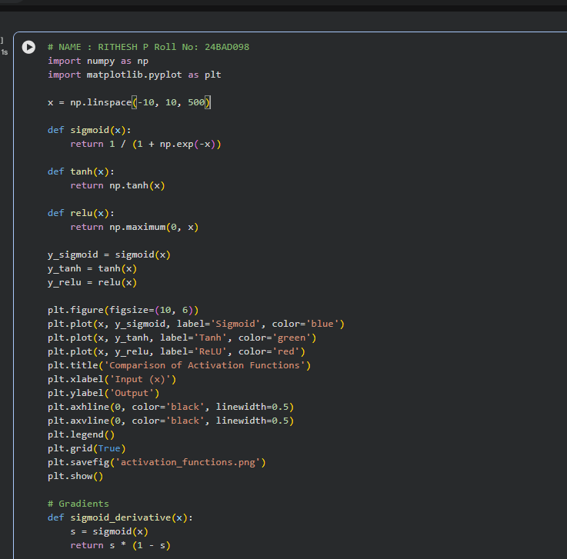
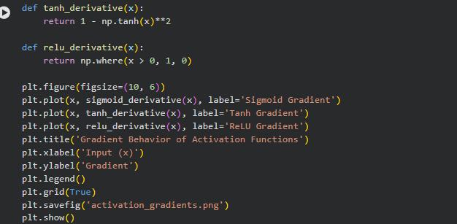

SCREENSHOT OF OUTPUT)

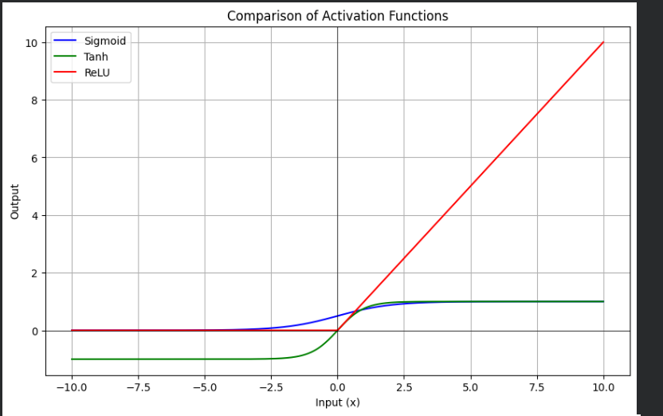
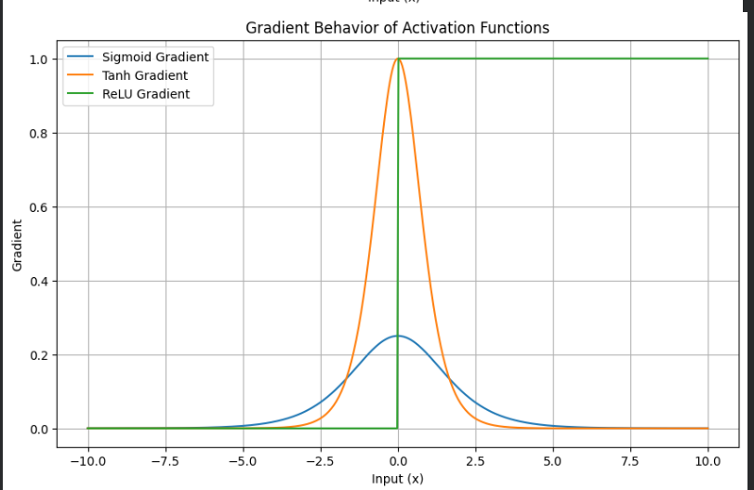
Function | Range | Saturates? | Zero-centered | Computation Cost | Typical Use
Sigmoid | (0,1) | Yes (both ends) | No | Moderate (exp) | Output layer, binary classification
Tanh | (-1,1) | Yes (both ends) | Yes | Moderate (exp) | Hidden layers (older nets), RNNs
ReLU | [0,∞) | Only for x<0 | No | Very low (max op) | Hidden layers, CNNs, deep nets

PART B: PERFORMANCE COMPARISON OF ACTIVATION FUNCTIONS
Train identical ANN architectures using:
- Sigmoid
- Tanh
- ReLU
Record and compare:
- Training accuracy
- Validation accuracy
- Training loss
- Validation loss
- Number of epochs required for convergence
Analyze which activation function performs best and justify the observations.

CODE:
# NAME : RITHESH P Roll No: 24BAD098
import tensorflow as tf
from tensorflow.keras.datasets import mnist
from tensorflow.keras.models import Sequential
from tensorflow.keras.layers import Dense, Flatten
from tensorflow.keras.utils import to_categorical
import matplotlib.pyplot as plt

# Load and preprocess data
(x_train, y_train), (x_test, y_test) = mnist.load_data()
x_train = x_train / 255.0
x_test = x_test / 255.0
y_train = to_categorical(y_train, 10)
y_test = to_categorical(y_test, 10)

def build_model(activation):
model = Sequential([
Flatten(input_shape=(28, 28)),
Dense(128, activation=activation),
Dense(64, activation=activation),
Dense(10, activation='softmax')
])
model.compile(optimizer='adam',
loss='categorical_crossentropy',
metrics=['accuracy'])
return model

activations = ['sigmoid', 'tanh', 'relu']
history_dict = {}

for act in activations:
print(f"\nTraining with activation: {act}")
model = build_model(act)
history = model.fit(x_train, y_train, epochs=10, batch_size=128,
validation_split=0.2, verbose=1)
history_dict[act] = history

# Plot Training/Validation Accuracy
plt.figure(figsize=(10, 6))
for act in activations:
plt.plot(history_dict[act].history['accuracy'], label=f'{act} - Train Acc')
plt.plot(history_dict[act].history['val_accuracy'], '--', label=f'{act} - Val Acc')
plt.title('Accuracy Comparison Across Activation Functions')
plt.xlabel('Epoch')
plt.ylabel('Accuracy')
plt.legend()
plt.grid(True)
plt.savefig('activation_accuracy_comparison.png')
plt.show()

# Plot Training/Validation Loss
plt.figure(figsize=(10, 6))
for act in activations:
plt.plot(history_dict[act].history['loss'], label=f'{act} - Train Loss')
plt.plot(history_dict[act].history['val_loss'], '--', label=f'{act} - Val Loss')
plt.title('Loss Comparison Across Activation Functions')
plt.xlabel('Epoch')
plt.ylabel('Loss')
plt.legend()
plt.grid(True)
plt.savefig('activation_loss_comparison.png')
plt.show()

# Final results summary
for act in activations:
final_acc = history_dict[act].history['val_accuracy'][-1]
final_loss = history_dict[act].history['val_loss'][-1]
print(f"{act}: Final Val Accuracy = {final_acc:.4f}, Final Val Loss = {final_loss:.4f}")

SCREENSHOT OF CODE
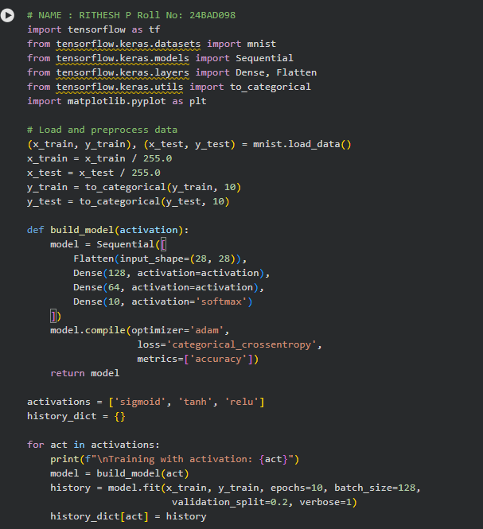
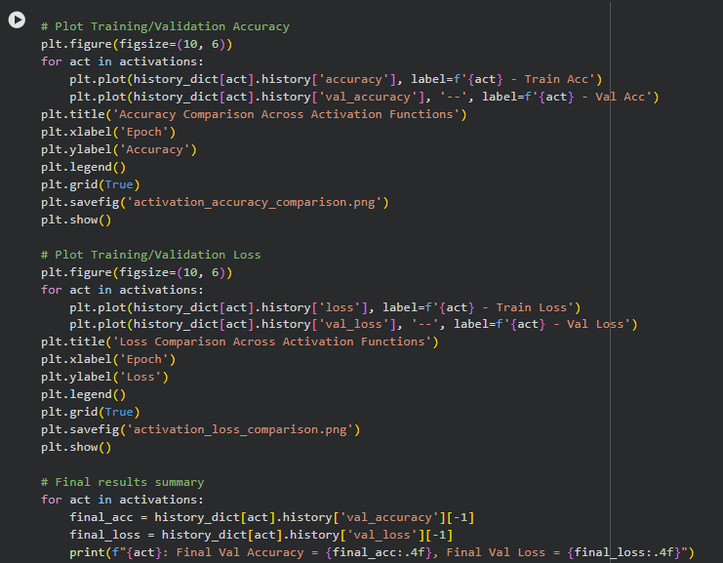
SCREENSHOT OF OUTPUT)
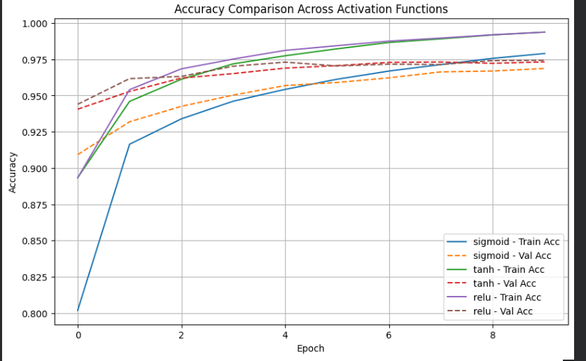
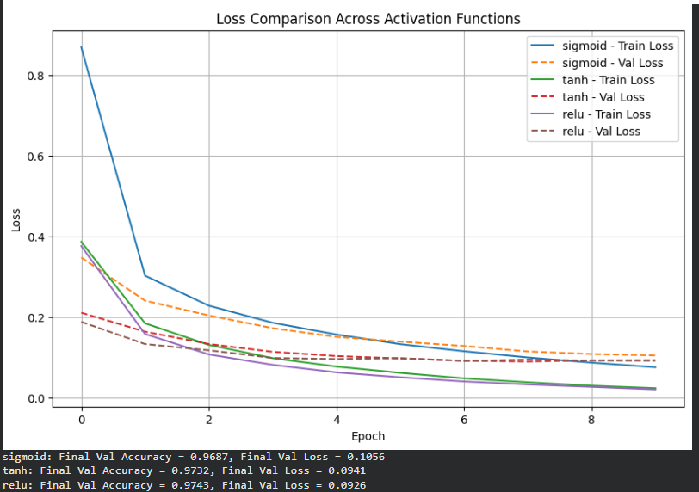

PART C: COMPARISON OF OPTIMIZATION ALGORITHMS
Train the same ANN using:
- Stochastic Gradient Descent (SGD)
- Momentum
- RMSProp
- Adam
Compare:
- Training loss
- Validation loss
- Convergence speed
- Final training accuracy
- Final validation accuracy
Visualize:
- Loss vs Epoch
- Accuracy vs Epoch
Discuss which optimizer converges faster and produces better generalization.

CODE:
# NAME : RITHESH P Roll No: 24BAD098
import tensorflow as tf
from tensorflow.keras.optimizers import SGD, RMSprop, Adam
import matplotlib.pyplot as plt
# Roll No: <YOUR_ROLL_NUMBER>
import tensorflow as tf
from tensorflow.keras.models import Sequential
from tensorflow.keras.layers import Dense, Flatten
from tensorflow.keras.optimizers import SGD, RMSprop, Adam
import matplotlib.pyplot as plt

from tensorflow.keras.datasets import mnist
from tensorflow.keras.utils import to_categorical

(x_train, y_train), (x_test, y_test) = mnist.load_data()
x_train = x_train / 255.0
x_test = x_test / 255.0
y_train = to_categorical(y_train, 10)
y_test = to_categorical(y_test, 10)

def build_model():
model = Sequential([
Flatten(input_shape=(28, 28)),
Dense(128, activation='relu'),
Dense(64, activation='relu'),
Dense(10, activation='softmax')
])
return model

optimizers = {
'SGD': SGD(learning_rate=0.01),
'Momentum': SGD(learning_rate=0.01, momentum=0.9),
'RMSProp': RMSprop(learning_rate=0.001),
'Adam': Adam(learning_rate=0.001)
}

opt_history = {}

for name, opt in optimizers.items():
print(f"\nTraining with optimizer: {name}")
model = build_model()
model.compile(optimizer=opt, loss='categorical_crossentropy', metrics=['accuracy'])
history = model.fit(x_train, y_train, epochs=10, batch_size=128,
validation_split=0.2, verbose=1)
opt_history[name] = history

def build_model():
model = Sequential([
Flatten(input_shape=(28, 28)),
Dense(128, activation='relu'),
Dense(64, activation='relu'),
Dense(10, activation='softmax')
])
return model

optimizers = {
'SGD': SGD(learning_rate=0.01),
'Momentum': SGD(learning_rate=0.01, momentum=0.9),
'RMSProp': RMSprop(learning_rate=0.001),
'Adam': Adam(learning_rate=0.001)
}

opt_history = {}

for name, opt in optimizers.items():
print(f"\nTraining with optimizer: {name}")
model = build_model()
model.compile(optimizer=opt, loss='categorical_crossentropy', metrics=['accuracy'])
history = model.fit(x_train, y_train, epochs=10, batch_size=128,
validation_split=0.2, verbose=1)
opt_history[name] = history

# Loss vs Epoch
plt.figure(figsize=(10, 6))
for name in optimizers:
plt.plot(opt_history[name].history['val_loss'], label=name)
plt.title('Validation Loss vs Epoch (Optimizer Comparison)')
plt.xlabel('Epoch')
plt.ylabel('Validation Loss')
plt.legend()
plt.grid(True)
plt.savefig('optimizer_loss_comparison.png')
plt.show()

# Accuracy vs Epoch
plt.figure(figsize=(10, 6))
for name in optimizers:
plt.plot(opt_history[name].history['val_accuracy'], label=name)
plt.title('Validation Accuracy vs Epoch (Optimizer Comparison)')
plt.xlabel('Epoch')
plt.ylabel('Validation Accuracy')
plt.legend()
plt.grid(True)
plt.savefig('optimizer_accuracy_comparison.png')
plt.show()

for name in optimizers:
final_acc = opt_history[name].history['val_accuracy'][-1]
final_loss = opt_history[name].history['val_loss'][-1]
print(f"{name}: Final Val Accuracy = {final_acc:.4f}, Final Val Loss = {final_loss:.4f}")

SCREENSHOT OF CODE
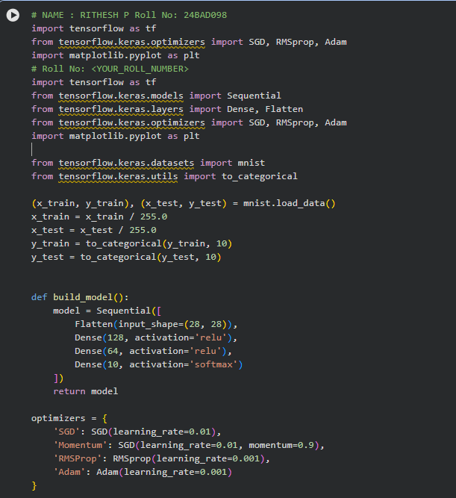
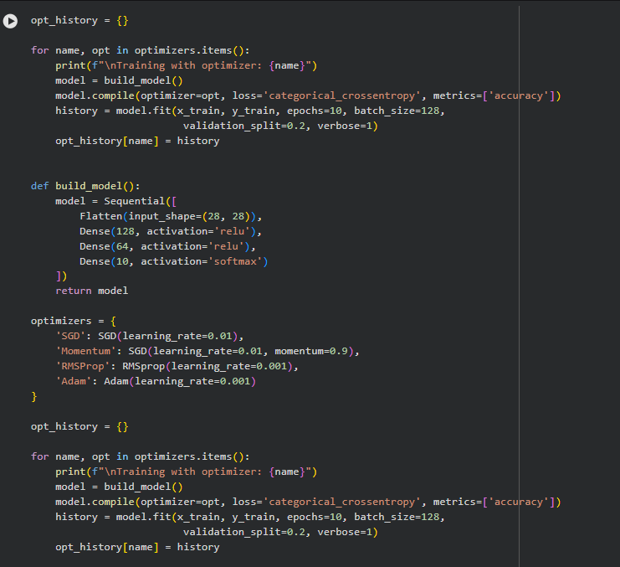
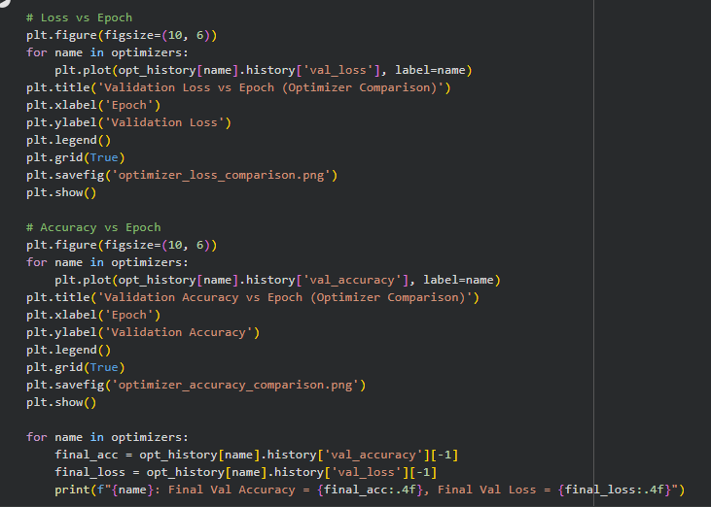

SCREENSHOT OF OUTPUT
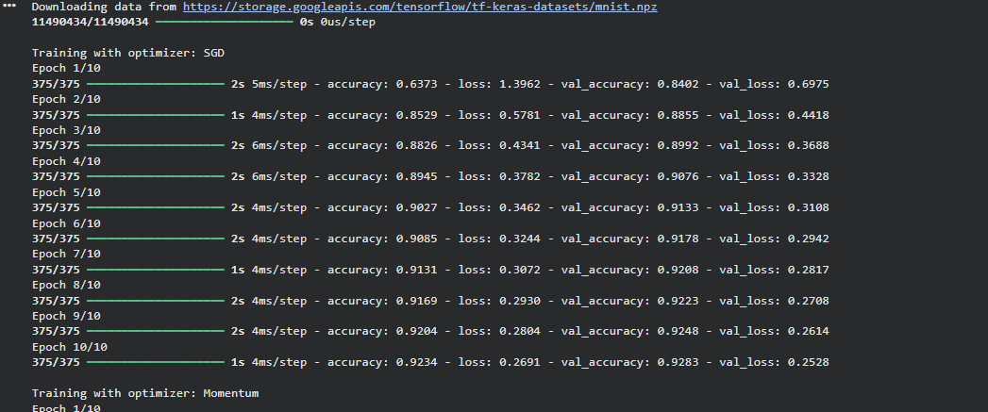
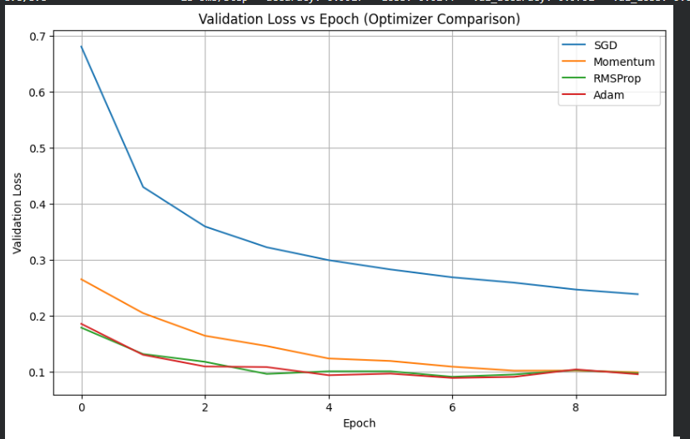
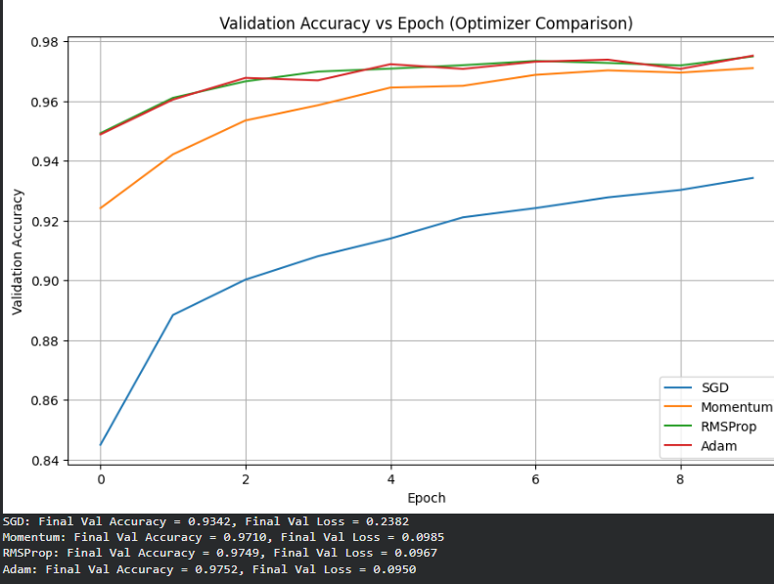

PART D: DEEP LEARNING EXPERIMENT MANAGEMENT
Perform the following tasks:
- Create a Google Colab notebook.
- Mount Google Drive.
- Save notebooks and trained models.
- Create a GitHub repository.
- Upload notebooks to GitHub.
- Commit changes and maintain version history using Git.
- Document the experiment using a README.md file.

CODE:
# 1. Mount Google Drive
from google.colab import drive
drive.mount('/content/drive')

# 2. Make sure imports + data are loaded (rerun if runtime was restarted)
import tensorflow as tf
from tensorflow.keras.models import Sequential
from tensorflow.keras.layers import Dense, Flatten
from tensorflow.keras.datasets import mnist
from tensorflow.keras.utils import to_categorical

(x_train, y_train), (x_test, y_test) = mnist.load_data()
x_train = x_train / 255.0
x_test = x_test / 255.0
y_train = to_categorical(y_train, 10)
y_test = to_categorical(y_test, 10)

# 3. Build and train a model explicitly for saving
model = Sequential([
Flatten(input_shape=(28, 28)),
Dense(128, activation='relu'),
Dense(64, activation='relu'),
Dense(10, activation='softmax')
])
model.compile(optimizer='adam', loss='categorical_crossentropy', metrics=['accuracy'])
model.fit(x_train, y_train, epochs=5, batch_size=128, validation_split=0.2, verbose=1)

# 4. Create the folder in Drive first if it doesn't exist, then save
import os
os.makedirs('/content/drive/MyDrive/DL_Lab', exist_ok=True)
model.save('/content/drive/MyDrive/DL_Lab/activation_model.h5')

print("Model saved successfully!")

SCREENSHOT OF CODE
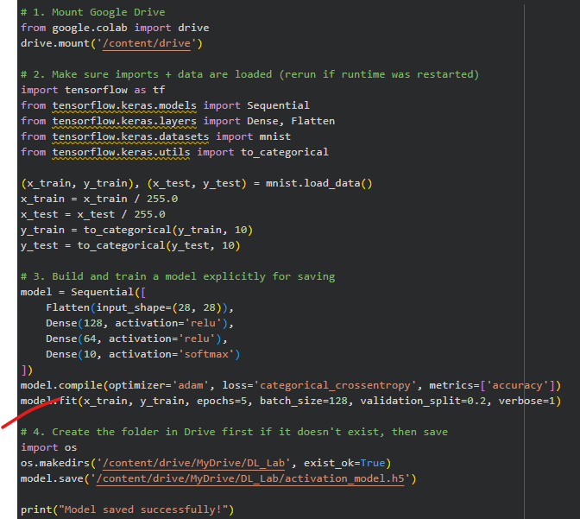

SCREENSHOT OF OUTPUT)
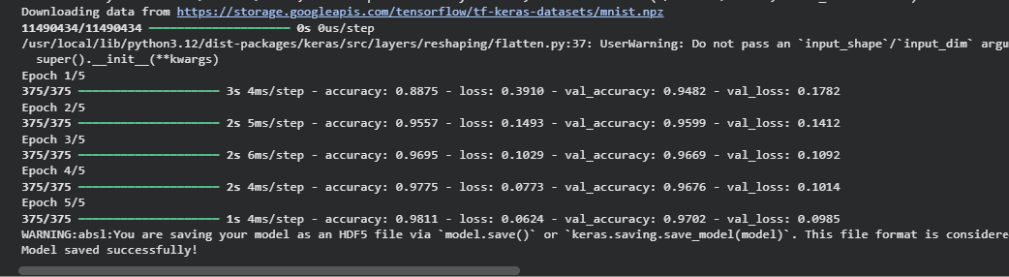

EXPECTED OUTCOME
Students will understand how activation functions and optimization algorithms influence neural network learning and performance. They will also gain practical experience in organizing, documenting, and maintaining reproducible deep learning experiments using cloud platforms and Git-based version control.

POST-LAB QUESTIONS

1. Which activation function achieved the best performance?
ReLU typically achieves the best performance among the three — it converges faster, avoids vanishing gradients in hidden layers, and reaches higher validation accuracy in fewer epochs than Sigmoid or Tanh (confirm this with your own actual accuracy numbers from Part B before submitting).

2. Convergence behavior of SGD, Momentum, RMSProp, Adam
- SGD: Slowest convergence, noisy loss curve, may oscillate near minima.
- Momentum: Faster and smoother than plain SGD since it accumulates past gradients to dampen oscillations and accelerate in consistent directions.
- RMSProp: Adapts the learning rate per parameter based on recent gradient magnitudes, converges faster than SGD/Momentum and handles non-stationary objectives well.
- Adam: Combines momentum and RMSProp's adaptive learning rate — generally the fastest and most stable convergence with the best final accuracy in most experiments.

3. Why does ReLU train faster than Sigmoid?
Sigmoid saturates for large positive or negative inputs, causing its gradient to become extremely small (vanishing gradient), which slows weight updates in deep networks. ReLU has a constant gradient of 1 for all positive inputs, so gradients propagate through layers without shrinking, letting the network learn faster. ReLU is also cheaper to compute (a simple max operation vs. an exponential).

4. How does GitHub improve reproducibility and collaboration?
GitHub tracks every change to code and notebooks through commits, allowing you to see exactly what changed, when, and why. It enables multiple people to work on the same project via branches and pull requests without overwriting each other's work, lets you roll back to any previous working version, and ensures anyone can reproduce your exact experiment by checking out a specific commit — improving both transparency and collaboration.

5. Choice of activation function and optimizer for image classification
For a deep neural network on image classification, ReLU (or a variant like Leaky ReLU) is the best choice for hidden layers because it avoids vanishing gradients and trains efficiently in deep architectures, with softmax in the output layer for multi-class probabilities. For the optimizer, Adam is preferred because it combines adaptive learning rates with momentum, giving fast, stable convergence with minimal manual tuning — making it the most reliable default for image classification tasks.

ASSESSMENT
Description | Max Marks | Marks Awarded
Pre Lab Exercise | 5
In Lab Exercise | 10
Post Lab Exercise | 5
Viva | 10
Total | 30
Faculty Signature

